Alfiya Subair
[company name]
JOB PORTAL SYSTEM

TABLE OF CONTENTS

S.NO | CONTENTS | PAGE NO.
1  2  3  4  5 | INTRODUCTION  Purpose  Scope  Objectives  FUNCTIONAL REQUIREMENTS  Primary actors of the system  Use case diagram  User stories  Business process diagram  NON- FUNCTIONAL REQUIREMENTS  TECHNICAL REQUIREMENTS  CONCLUSION

JOB PORTAL
Software Requirements Specification (SRS)
Project for .NetCore/Angular Training Boot Camp

INTRODUCTION
A job portal system is an online platform designed to bridge the gap between job seekers and employers, streamlining the recruitment process. It provides a centralized space where employers can post job openings and search for qualified candidates, while job seekers can explore opportunities, submit applications, and showcase their skills through detailed profiles. By fostering connectivity and accessibility, it empowers individuals to find their ideal roles and organizations to discover top talent efficiently.
PURPOSE
The purpose of a job portal system is to connect job seekers with employers in a streamlined and efficient manner. It simplifies the hiring process by providing a platform where candidates can easily find job opportunities, submit applications, and manage their profiles, while employers can post job listings, review resumes, and identify suitable candidates.
SCOPE
The scope of a job portal system includes providing a platform for job seekers to find and apply for job opportunities, while enabling employers to post job openings and search for qualified candidates. It supports features such as resume management, job search filters, application tracking, and candidate matching. The system can cater to various industries, job roles, and skill levels, offering a wide reach to both local and global job markets.
OBJECTIVES
The objectives of a job portal system are to simplify the recruitment process for both job seekers and employers. For job seekers, the goal is to provide an easy-to-use platform to search for relevant job opportunities, create profiles, and submit applications. For employers, the objective is to offer a streamlined way to post job openings, review applications, and find qualified candidates quickly. The system also aims to enhance efficiency by offering features like job matching, resume management, and application tracking, ultimately improving the overall hiring experience for all users.

FUNCTIONAL REQUIREMENTS

PRIMARY ACTORS OF THE SYSTEM
The primary actors of a job portal system are job seekers, employers, and administrators. Job seekers are individuals looking for job opportunities, who create profiles, search for jobs, and submit applications. Employers are organizations or recruiters who post job listings, review applications, and select candidates for interviews. Administrators manage and maintain the system, ensuring smooth operations, user support, and data security.
JOB SEEKER
A job seeker is an individual looking for employment opportunities. They create a profile on the job portal, upload their resume, and search for jobs that match their skills and interests. Job seekers apply to positions they are interested in and may track their application status through the portal. They aim to find the best job that suits their qualifications and career goals.
JOB PROVIDERS
Job providers are employers or organizations that offer job opportunities. They post job openings on the job portal, review applications, and select candidates for interviews. Job providers aim to find qualified individuals to fill their available positions and meet their staffing needs.
PLATFORM ADMIN
A platform admin is responsible for managing and maintaining the job portal system. They ensure that the platform runs smoothly, handle user support, and monitor security. Admins also manage user accounts, approve job postings, and ensure the system is up to date with accurate information. They play a key role in keeping the platform secure and user-friendly.

USER CASE DIAGRAMS
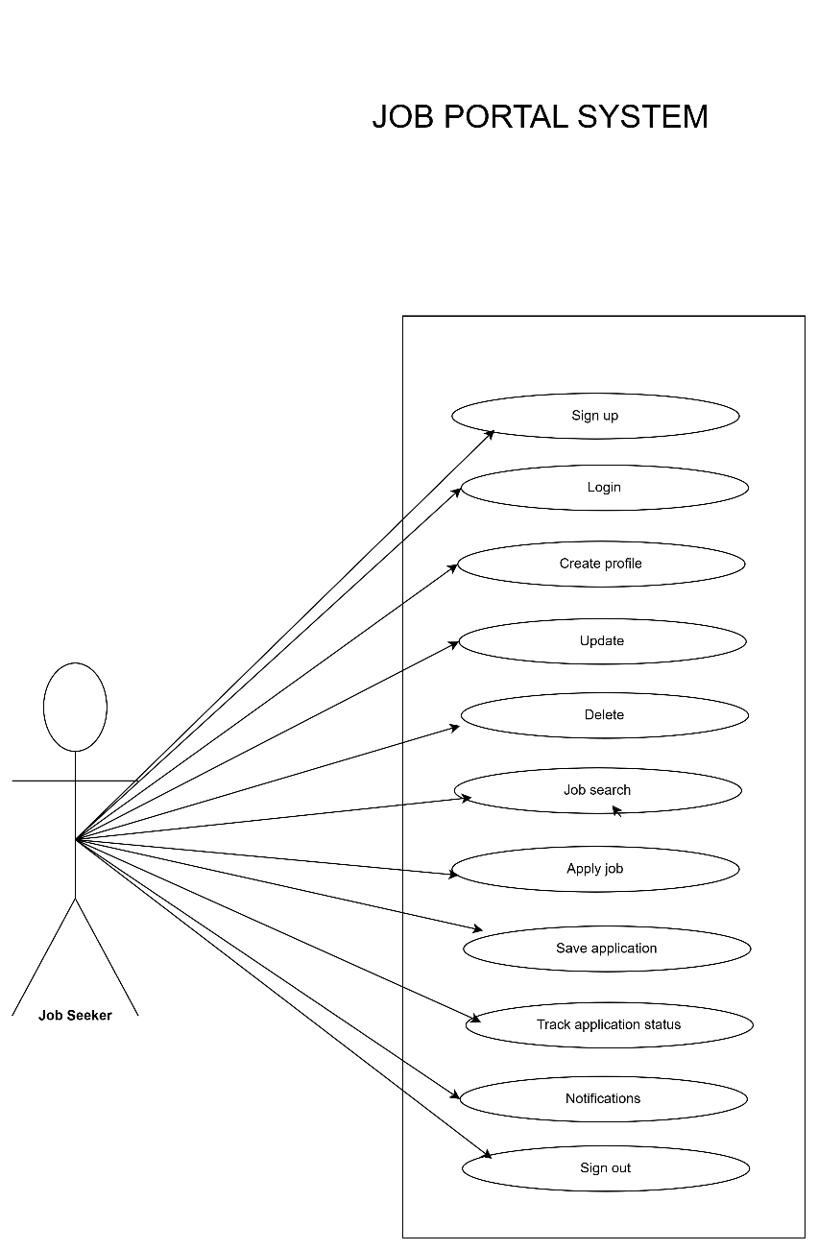

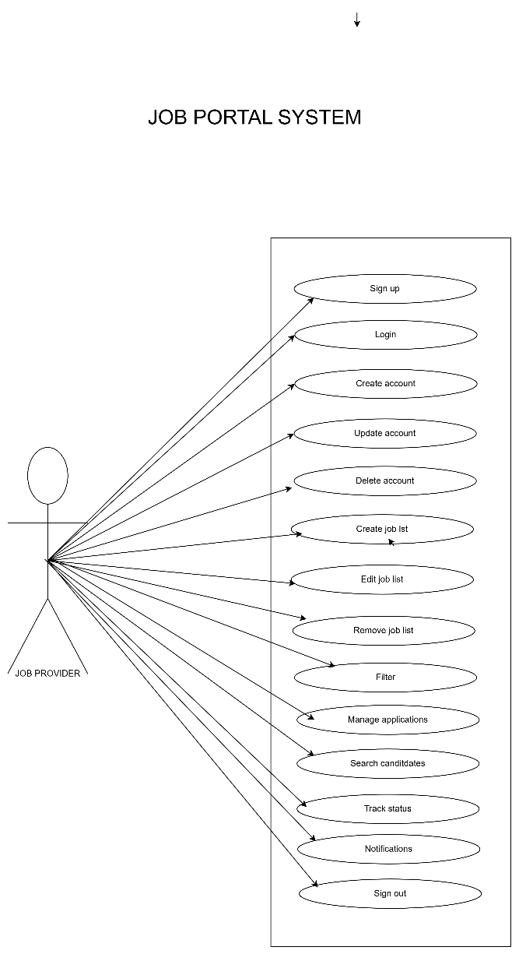

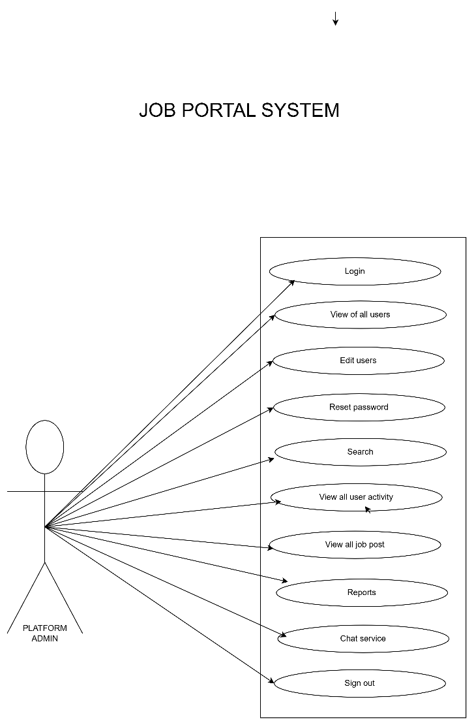

USER STORIES
- Job seeker

AS | I NEED TO | SO THAT I CAN
Job Seeker | Sign up using my email and secure password. | Enter the job portal system.
Job Seeker | A confirmation email received after sign up. | Account is created.
Job Seeker | Verify phone number through otp. | Account information is being validated.
Job Seeker | Login using email and password. | Access my account.
Job Seeker | Reset password if it is forgotten. | Regain my account.
Job Seeker | Reset new password with link. | Create a new password.
Job Seeker | Create a profile | Add essential needs to then profile.
Job Seeker | Update by information. | Details can be accurate.
Job Seeker | Delete my profile. | Remove all my information and data from the platform.
Job Seeker | Search jobs here. | Find many jobs on this platform.
Job Seeker | Mention about the convenient location. | Be able to sort out jobs regarding that.
Job Seeker | Set salary preferences. | See jobs related to the given information.
Job Seeker | Mention about the job type(part time/full time). | Get the preferences according to that.
Job Seeker | Mention about the correct areas of jobs. | Easily helps to find different categories of jobs.
Job Seeker | Get alert about my profile progress. | It helps to get alerts according to the mentioned filters about job title.
Job Seeker | Need to view and apply for the jobs. | Able to find jobs on this platform.
Job Seeker | Need to search for jobs according to my desires. | Quickly be able to find jobs according to my interest.
Job Seeker | Need to upload my resume/cover letter and other essential things. | That helps to submit my application in the correct way.
Job Seeker | Need to apply for jobs by filling out. | Apply for a job without any problem.
Job Seeker | Save my application and complete it later. | Which allows my time convenience to complete and submit later.
Job Seeker | Want to track the status of my application. | Which can know whether it is shortlisted,rejected or further steps.
Job Seeker | Need to receive notifications | Get to know about the details of the status of the jobs.
Job Seeker | Need to receive job alerts from new job listings. | Apply as soon as possible.
Job Seeker | Need to know whether the employer had received or seened the application. | Take further steps.
Job Seeker | Need to receive a notification whether invited for an interview or not. | I can confirm my availability and preparation.
Job Seeker | Able to receive alerts about the expiring dates. | Be able to submit the application as soon as possible.
Job Seeker | Be able to upload the certificates if they have been asked. | That the employers can view all the certificates and to know about qualifications.
Job Seeker | Sign out of my account. | Ensure my account is secure when I am done.

- Job provider
AS | I NEED TO | SO THAT I CAN
Job Provider | Sign up using my email and secure password | Create an account to access the job portal service.
Job Provider | Receive a confirmation email after sign up | Know my account was successfully created.
Job Provider | Verify my phone number via an OTP | Know my account information is validated.
Job Provider | Login using my email and password | Access my account
Job Provider | Reset my password If I forget it | Regain access my account.
Job Provider | Receive a password reset link via email | Create a new password.
Job Provider | Create a company profile with my branding and values | Attract candidates who align with my organization.
Job Provider | Update basic company details | My profile reflects the latest information.
Job Provider | Delete my company profile | It is no longer visible on the platform if my organization no longer operates.
Job Provider | Create a new job listing | Attract suitable candidate.
Job Provider | Add job details such as title description, requirements, and location | Applicant understand the role and its expectations.
Job Provider | Specify the types of jobs (fulltime, part time, freelance) | Applicants know the nature of the position
Job Provider | Include salary or compensation information | Attract the right candidates.
Job Provider | Edit an existing job post | Update any outdated information.
Job Provider | Remove and deactivate a job post | It is no longer visible when the position is fulfilled.
Job Provider | Highlight my job post as featured | It appears prominently to job seekers.
Job Provider | Filter through job applications | Easily find suitable candidates.
Job Provider | Receive notifications when someone applies | Respond quickly.
Job Provider | View analytics for my job post | Measure the respond rate.
Job Provider | Manage applicants for my job postings | Find the best fit for the position.
Job Provider | View a list of applicants for each job postings | Review their profiles.
Job Provider | Filter applications by skills, experience and qualifications | Identify the most relevant candidates.
Job Provider | Search for candidates by location | Find individuals who are based near the job sites
Job Provider | Search candidates based on their availability such as immediate, within a month | Match their timeline with my hiring needs.
Job Provider | Track the status of each applicant such as shortlisted, interviewed, rejected | Manage the hiring process efficiently.
Job Provider | Download resume and portfolios | Review them offline.
Job Provider | Export application data to my HR system | Integrate it with my internal workflow.
Job Provider | I need to see a summary of my active job postings, candidate applications, and recent activity on the dashboard | Get a quick overview of my account.
Job Provider | Send messages to applicants directly through the platform | Communicate without sharing personal contact details.
Job Provider | Send interview invitations to shortlisted candidates | Schedule meeting easily.
Job Provider | Send rejection notification to candidates | They are informed about their application status.
Job Provider | Receive reminders about expiring job postings | Renew or update them.
Job Provider | Notified of platform updates or new features | Use them effectively.
Job Provider | Notified when a candidate updates their applications or profile | I have the latest information
Job Provider | Notified pending task such as reviewing applications, scheduling interviews | Ensure timely actions.
Job Provider | Alerted when my job post is expiring or inactive | Take necessary actions.
Job Provider | Sigh out from any device I am logged | Ensure that my account is secure.

- Platform admin
AS | I NEED TO | SO THAT I CAN
Platform Admin | Create a login by entering details | access to job portal system
Platform Admin | Verify phone number via OTP | Do Verification process
Platform Admin | View a list of all user accounts with filters | Find status of accounts like in active,active,suspended
Platform Admin | View detailed profiles of user | Verify their identity ,roles and activity logs
Platform Admin | Deactivate user accounts | Users violating policies are restricted from accessing the platform
Platform Admin | Permanently delete user accounts | Remove users who don't need the platform or are flagged as fake
Platform Admin | Edit user profiles | Correct errors or remove inappropriate content
Platform Admin | Reset user passwords upon request | Users who cannot access their accounts can login again
Platform Admin | Trigger password reset emails to users | Update their passwords securely
Platform Admin | Search for users by specific attributes like email,username,status | Quickly locate the account
Platform Admin | View the activity logos of a specific user like login history, job applications | Monitor suspicious or in appropriate behaviour
Platform Admin | View all job post on the platform with filters | I can monitor the platform activity
Platform Admin | Review and approve job posts submitted by recruiters | Only real and valuable opportunities are posted on the platform.
Platform Admin | Reject job posts | Reject job post violated platform policies
Platform Admin | Delete job posts | Maintains platform integrity and quality
Platform Admin | Provide feedback when rejecting a job post | Recruiters can understand correct issues
Platform Admin | Review job posts reported by users | Investigate and take appropriate action
Platform Admin | Generate reports on job posts by category, industry or location | Share insights with the business team
Platform Admin | Generate reports on job posts like most popular industries, locations | Identify trends and improve the platform
Platform Admin | Sign out | Secure my account from others

BUSINESS PROCESS DIAGRAM
- Job seekers
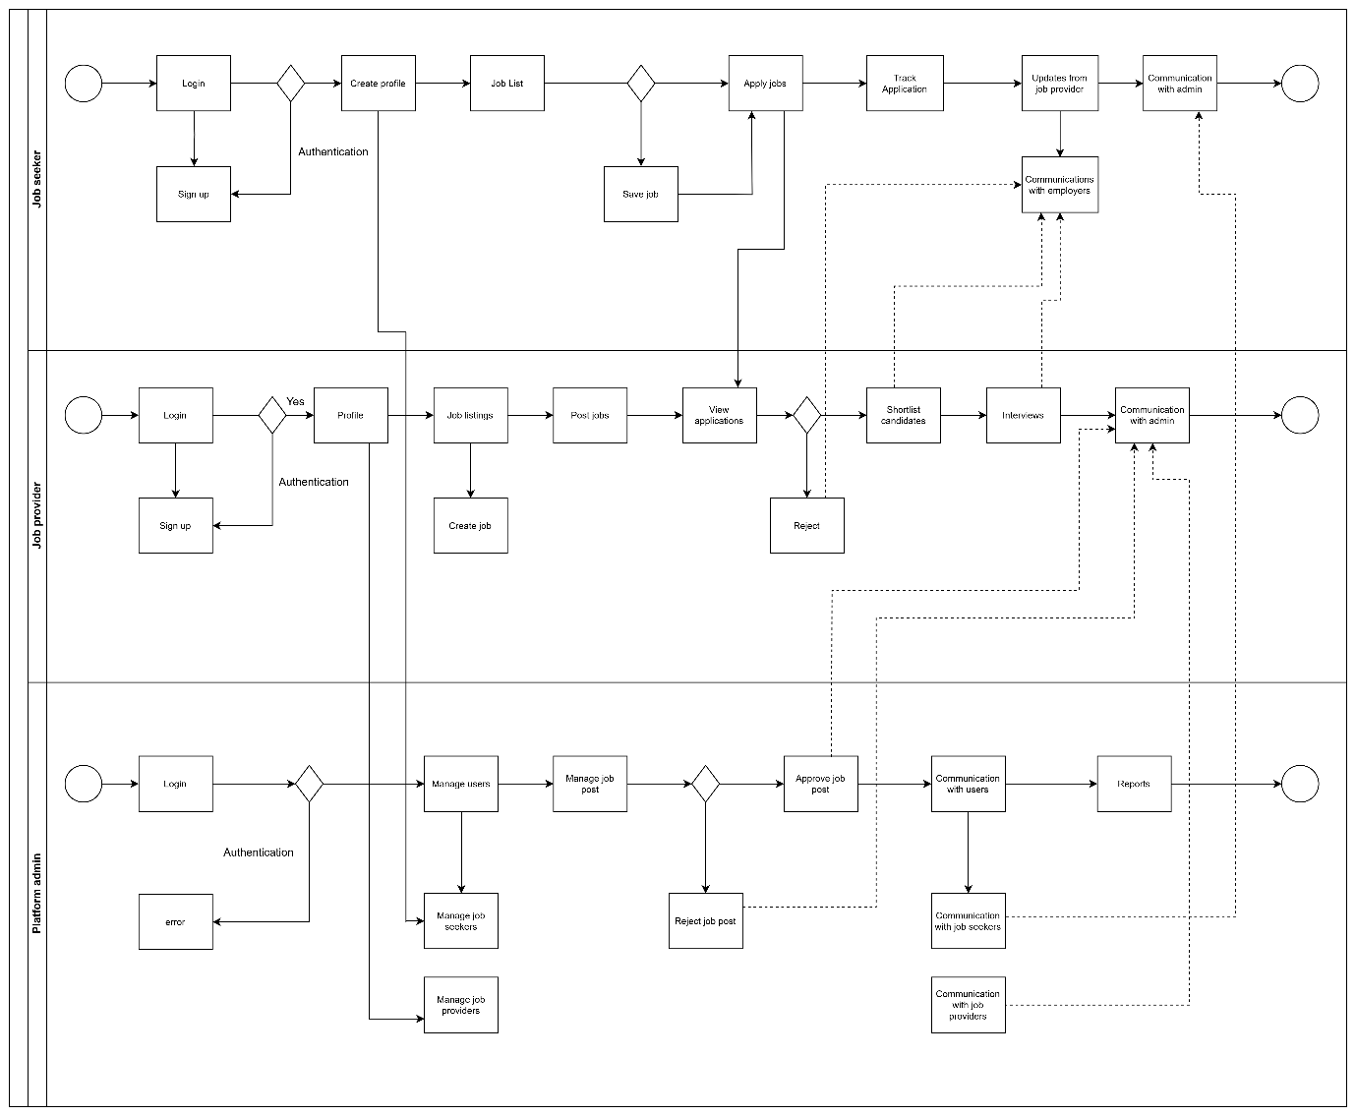

- Job providers
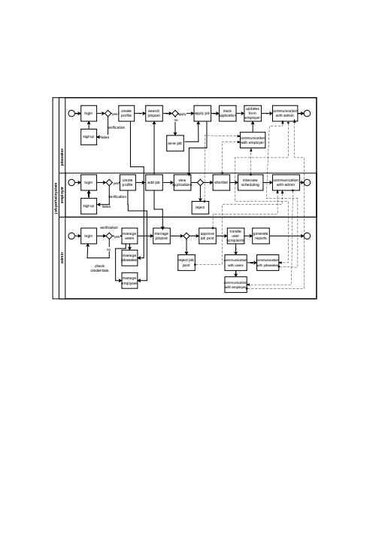

- Platform admin
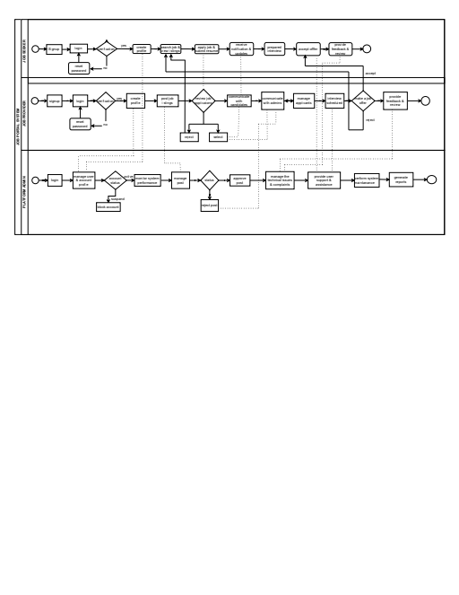

NON -FUNCTIONAL REQUIREMENTS

